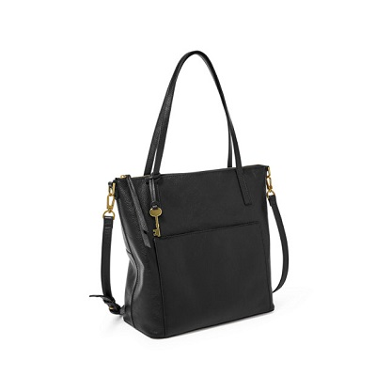

Evelyn Medium Tote

PRODUCT DETAILS

**Silhouette: Medium Tote**

**Tech Compatibility: iPhone® XS Max, 10.5" iPad® Pro**

**Exterior Material: Leather/Polyurethane Trim**

**Interior Details: 1 Zipper Pocket, 2 Slide Pockets**

**Measurements: 11.75"L x 5.38"W x 11.75"H**

**Handles/Straps: 1 Adjustable & Detachable Crossbody Strap, 2 Shoulder Straps**